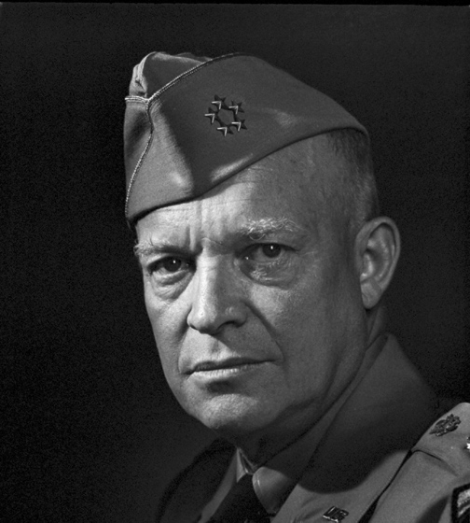
Chapter 14 Targets
The U.S. in World War II

14.1 The War in Europe & North Africa
- Define the terms wolf pack and convoy system.
- Explain why the control of the seas was so important for the Allies and the Axis.
- Evaluate the effectiveness of the Allied Powers approach in making the Germans fight a “three-front war.”
- Examine the goals of Operation Torch.
- Discuss the military impact of the invasion of Normandy.

14.2 The Holocaust
- Recall reasons why anti-Semitism existed in Germany during the 1930s.
- Create a short timeline of events the Jews of Germany had to endure once Hitler came to power in 1933.
- Examine the purpose of Hitler’s “Final Solution.”
- Evaluate the effectiveness of President Roosevelt’s War Refugee Board (1944).
- Defend the United States delay to intervene in the Holocaust.
- Generalize the historical significance of the Nuremberg trials.

14.3 The War in the Pacific
- Recall the events that led to the Bataan Death March.
- Analyze Japan’s steps to control the Pacific in the early years of war.
- Briefly describe five major battles in the Pacific campaign.
- Identify Japan’s act of desperation by using kamikaze pilots.
- Evaluate the impact of Native Americans soldiers who served in WWII (specifically the Navajo Indians).

14.4 The Home Front
- Recall the purpose of rationing and scrap drives.
- Describe the purpose of the Office of War Information.
- Examine the decision of West VA Board of Education v. Barnette (1943).
- Explain the difference between a concentration camp and an internment camp.
- Justify a Japanese family’s resentment and distrust of the American government after WWII.

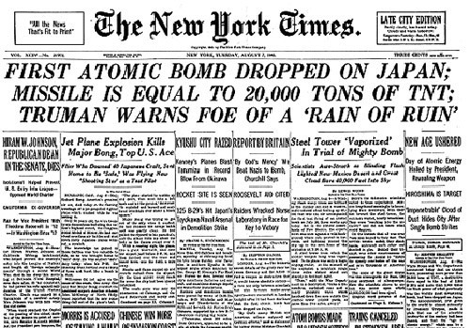
14.5 World War II Ends
- Explain what the Allies decided during the conference at Yalta in February 1945.
- Evaluate Eisenhower’s decision to allow the Russians to “conquer” Berlin first.
- Predict how the decision to drop the atomic bomb will affect the United States in the future.
- Critique President Truman’s decision to drop two atomic bombs on Japan.
- Describe the purpose of the United Nations.
- Recall the fate of the leaders of Nazi Germany and Imperial Japan after the war.

