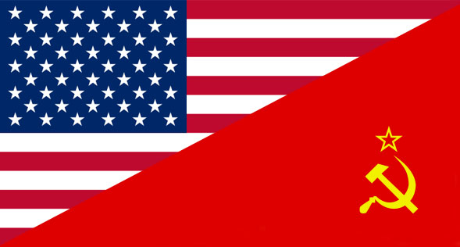
Chapter 15 Targets
The Cold War Begins

15.1 The Iron Curtain Falls on Europe
- Identify the years the Cold War took place.
- Evaluate the ideological differences between the United States and the Soviet Union during the 1940s.
- Define the term Iron Curtain.
- Predict the effectiveness of Kennan’s containment policy and the Truman Doctrine.
- Analyze the different ways the Marshall Plan benefitted the United States.
- Predict the relationship between the U.S. and U.S.S.R. after the Berlin airlift.
- Describe the purpose of NATO when a peacekeeping organization like the UN was already in existence.

15.2 Healing the Wounds of War
- Justify the creation of the GI Bill.
- List three reasons why there was a baby boom in the United States after WWII.
- Examine the significance of the 1948 presidential election.
- Summarize the United Nation’s “Universal Declaration of Human Rights.”
- Identify the purpose of the International Monetary Fund and the World Bank.

15.3 The Second Red Scare
- Recall how the Soviet detonation of an atomic bomb led to an uneasy feeling in the United States.
- Predict the future of Chinese-American relations after Mao came to power.
- Evaluate the purpose of the HUAC in American society.
- Describe the roles of Hiss, Fuchs, and the Rosenberg’s during the Second Red Scare.
- Analyze the impact of Senator Joseph McCarthy on American history.

15.4 The Korean War
- Define the function of the 38th parallel on the Korean Peninsula.
- Describe the events that led to a war in Korea (1950-53).
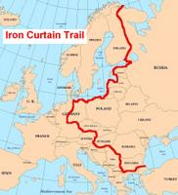
- Explain the role the United States will take in the Korean War.
- Recall the fallout between Truman and Douglas MacArthur.
- Evaluate the cost of the Korean War and how the United States “benefitted” from the war.
- Define the term armistice.

