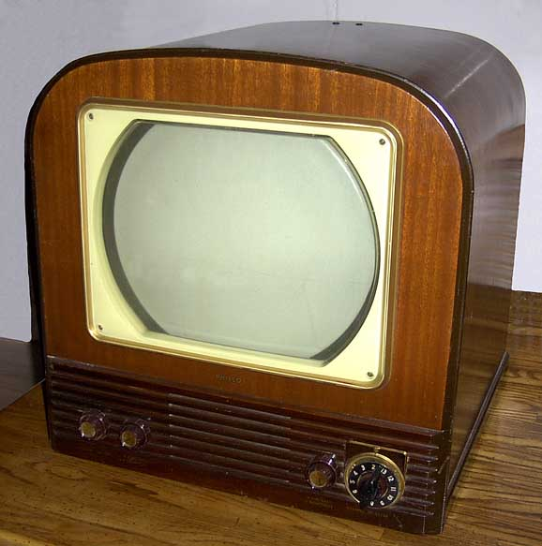
Chapter 16 Targets
Postwar America

16.1 The Eisenhower Era
- Identify three reasons why Americans “liked Ike.”
- Recall Eisenhower’s running mate Nixon’s Checkers speech.
- Compare the policies of brinkmanship and massive retaliation to the containment policy of the Truman administration.
- Describe the purpose of the Central Intelligence Agency.
- Evaluate the U.S.S.R.’s creation of the Warsaw Pact in response to the creation of NATO.
- Explain what Eisenhower meant when he compared Vietnam to a domino.
- Identify the region of the world the Eisenhower Doctrine focused.

16.2 Atomic Anxiety
- Compare the creation of the hydrogen bomb to the policy of militarism during the WWI era.
- Identify new technological advances in weaponry during the Eisenhower era.
- Recall the historical significance of the Sputnik launch in October 1957.
- Describe the impact of the Federal Civil Defense Administration on American society.
- Define the term military-industrial complex.

16.3 The Television Age
- Examine the affordability of the television and its impact on politics and consumerism in the 1950s.
- Recall the concerns about television’s impact on young views in the 1950s.
- Identify the year Americans could watch television in color.
- Define the terms transistor and integrated circuit.
- Describe the impact of the worst polio outbreak in U.S. History in 1952.
- Defend why Americans were part of an “affluent society” during the postwar era.
- Analyze the historical impact of Bill and Alfred Levitt.
- Predict the impact of a government funded Interstate Highway System on the future of the United States economically and socially.
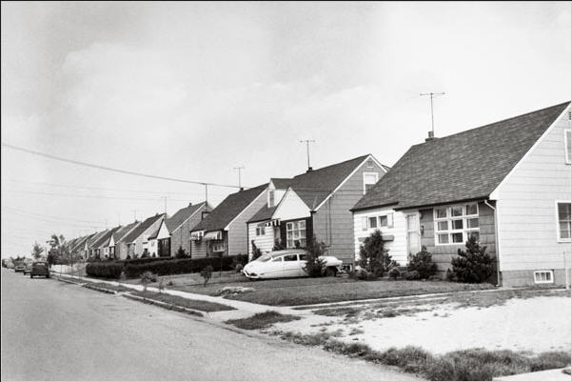
Levittown

