Chapter 17 Targets
The New Frontier & Great Society

17.1 Kennedy and the Cold War
- Explain how the election of 1960 is one of the most significant of the 20th century United States elections.
- Analyze the way Kennedy represented change to the American people.
- Describe the failure of the Bay of Pigs invasion.
- Identify the key reasons Kennedy and Russian Premier Khrushchev butted heads over the future of Germany in the early 1960s.
- Recall the events that led to the Cuban Missile Crisis. Examine the Kennedy administration’s “victory.”
- Evaluate the international purpose of the Peace Corps.
- Define the term flexible response.

17.2 Kennedy’s Thousand Days
- Describe the “New Frontier” Kennedy was advertising to the American people.
- Evaluate the liberal presence of the Warren Court. Identify the changes Earl Warren helped promote in American society.
- Examine the Kennedy assassination on the morale of the American people.
- Recall the outcome of the Warren Commission.
- Identify the roles that Jacqueline Kennedy and Lyndon Johnson played in President JFK’s life.

17.3 The Great Society
- Examine Lyndon B. Johnson’s political career prior to 1960.
- Defend Johnson’s “War on Poverty.”
- Recall the use of extremism Johnson initiated during his 1964 presidential campaign against Barry Goldwater.
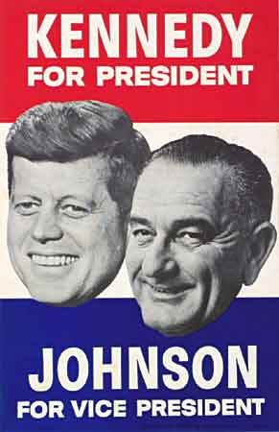
- Compare Lyndon B. Johnson’s Great Society to Franklin D. Roosevelt’s New Deal.
- Evaluate Johnson’s role in American domestic society.
- Explain how foreign policy issues damned LBJ’s potential presidential campaign in 1968.

