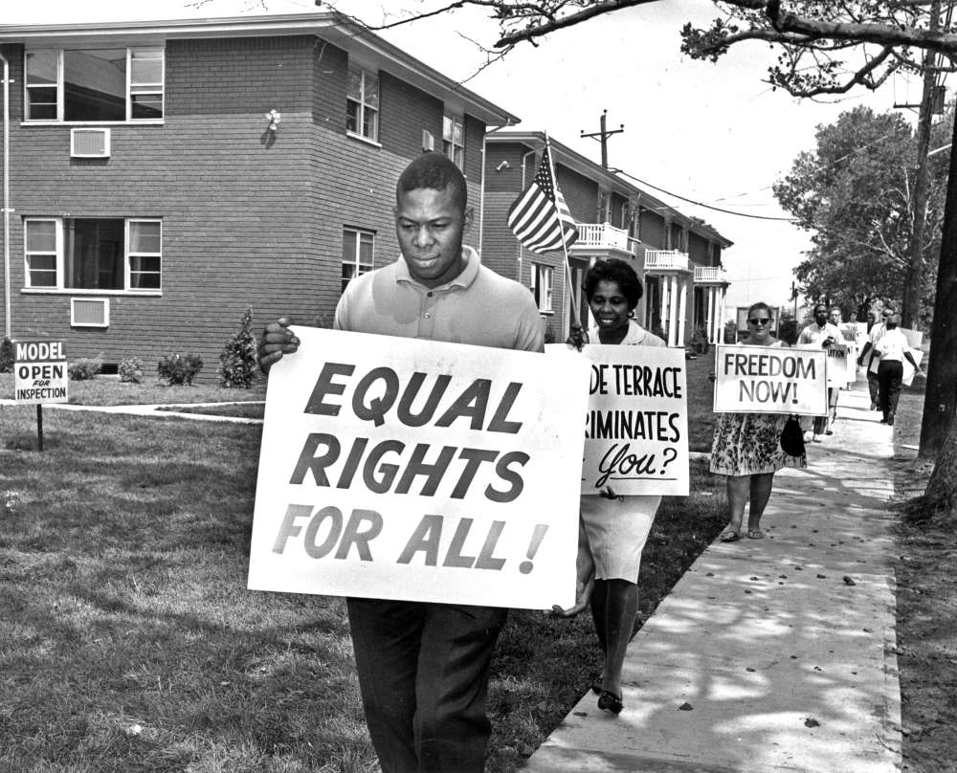
Chapter 18 Targets
The Civil Rights Movement

18.1 Fighting Segregation
- Describe how Jackie Robinson brought change to American society.
- Compare the institution CORE to what you know about the belief system of Martin Luther King Jr.
- Examine the immediate and lasting social impact of the Brown v. Board of Education of Topeka, Kansas ruling.
- Explain why president Eisenhower had to intervene in the Little Rock Nine’s integration into the public school system.
- Analyze the Rosa Parks story and predict the effectiveness of bus boycotts in the southern states.
- Describe the goal of the SCLC and its connection to MLK, Jr.

18.2 Freedom Now!
- Summarize the basic beliefs behind the tactic of nonviolence.
- Elaborate on the effectiveness of the sit-in movement.
- Describe the role of the NAACP during the civil rights era.
- Explain why MLK decided to leave Albany, Georgia and focus on a movement in Birmingham, Alabama.
- List some of the major components of the Civil Rights Act of 1964.
- Examine the goal of the March on Washington.

18.3 Voting Rights
- Define the purpose of the Voting Rights Act of 1965.
- Identify the goal of the Voter Education Project.
- Examine the social change the 24th Amendment brought to American society.
- Explain the historical impact of the Selma campaign (Alabama).

18.4 Changes and Challenges
- Define the terms de jure segregation and de facto segregation.
- List three movements that may have conflicted with MLK’s nonviolent campaign.
- Explain the reasons some African Americans would choose to follow men like Malcolm X during the early 1960s.
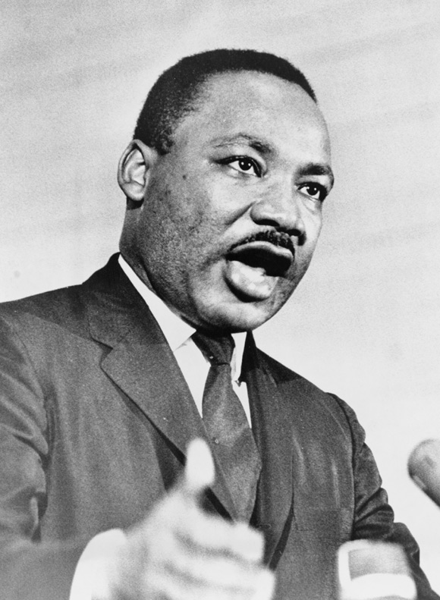
- Identify the urban response to MLK Jr.’s assassination in 1968.

18.5 The Movement Continues
- Identify who picked up the torch after King’s assassination.
- Analyze why the Poor People’s campaign failed.
- Describe how the FBI weakened the Black Panther Party.
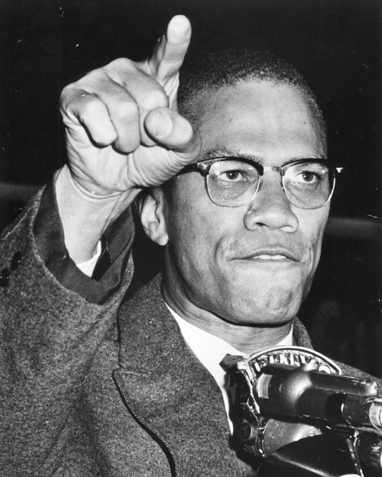
- Recall the major idea behind the Civil Rights Act of 1968.
- Define the term affirmative action.

